Color

📘 Definition
# Source: AI Source: Provided by: [Data Path: Persons Table -> ID Column: 1, Name_En Column: Motasem Essam] -> From: [ChatGPT] on [5/2/2026]
Color is the visual appearance of light as seen by our eyes. It is what lets us distinguish things like red, blue, green, and all other shades.

🌈 How color works
# Source: AI Source: Provided by: [Data Path: Persons Table -> ID Column: 1, Name_En Column: Motasem Essam] -> From: [ChatGPT] on [5/2/2026]
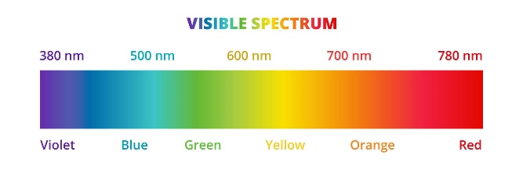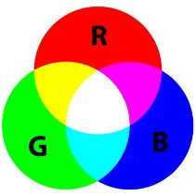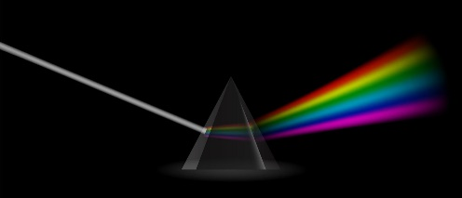
Color comes from light:
- When light hits an object, some parts are absorbed
- The rest is reflected into our eyes
- Our brain interprets that reflected light as a color
For example:
- A red apple looks red because it reflects red light and absorbs other colors

🎨 In graphics
# Source: AI Source: Provided by: [Data Path: Persons Table -> ID Column: 1, Name_En Column: Motasem Essam] -> From: [ChatGPT] on [5/2/2026]
In computer graphics, color is created using models like:
- RGB (Red, Green, Blue) – used in screens
- Different combinations of these colors produce millions of colors

🧠 Simple idea
# Source: AI Source: Provided by: [Data Path: Persons Table -> ID Column: 1, Name_En Column: Motasem Essam] -> From: [ChatGPT] on [5/2/2026]
- No light → you see black
- All colors of light together → you see white

🚀 In short:
# Source: AI Source: Provided by: [Data Path: Persons Table -> ID Column: 1, Name_En Column: Motasem Essam] -> From: [ChatGPT] on [5/2/2026]
Color = how our eyes see and interpret light.

